ORIGINAL RESEARCH
High-Sensitivity Cardiac Troponin I for Post-COVID Cardiovascular Risk Stratification in the Era of Artificial Intelligence: A Three-Year Longitudinal Cohort Study from a South Indian Tertiary Centre
Deepika Gujjarlapudi, MD¹ • Vidyavathi Devi Gajapathi Raju, MD² • Uma Mahesh K S S, MD² • Srihita Mahavadi, MD²
¹ Director & Head of Department, Biochemistry • ² Consultant, Department of Biochemistry
AIG Hospitals, Mind Space Road, Gachibowli, Hyderabad, Telangana 500032, India
Abstract
Background. The COVID-19 pandemic has left a cardiovascular legacy that extends well beyond the acute illness. SARS-CoV-2 injures the myocardium through direct viral invasion via ACE2 receptors, systemic cytokine-mediated inflammation, and a hypercoagulable state that promotes microvascular thrombosis. In those who survive — particularly those who develop Long COVID — these insults do not resolve cleanly. High-sensitivity cardiac troponin I (hs-cTnI), measured against sex-specific thresholds, detects subclinical myocardial injury missed by conventional assays. The emergence of artificial intelligence in clinical risk modelling opens the possibility of integrating multi-biomarker panels, demographic data, and illness severity into algorithms that predict individual cardiac trajectories with a precision no single test can achieve. This study characterises hs-cTnI-based cardiovascular risk across illness severities over three years and explores AI-augmented modelling for post-COVID cardiac risk prediction in an Indian tertiary centre population.
Methods. We conducted a retrospective longitudinal cohort study at AIG Hospitals, Hyderabad, between June 2020 and June 2023, enrolling 2,063 RT-PCR-confirmed COVID-19 patients (1,425 men, 638 women) after excluding those with pre-existing cerebrovascular disease, malignancy, or primary immunodeficiency. Illness severity was graded by WHO criteria into mild (n = 436), moderate (n = 820), and severe (n = 807) categories. Peak hs-cTnI was measured on the Abbott ARCHITECT i2000 and classified using sex-specific HUNT study thresholds. Five co-biomarkers — NT-proBNP, D-dimer, CRP, ferritin, and IL-6 — were measured in parallel. All patients were reassessed at six months. Statistical analyses included chi-square tests, odds ratios with 95% CIs, and logistic regression; an AI risk model was evaluated by five-fold cross-validation with ROC-AUC analysis.
Results. At baseline, 52.3% of patients had elevated hs-cTnI. Among those below the positivity threshold, 31.8% were classified as high-risk and 28.3% as moderate-risk — only four in ten apparently troponin-negative patients could be genuinely reassured. Men were nearly four times as likely as women to fall in the high-risk category (OR = 4.07, 95% CI: 2.50–6.60; χ² = 57.4, p < 0.001). Six-month follow-up documented substantial ongoing deterioration: 63.0% of initially low-risk men with severe illness had migrated to high-risk or overt troponin positivity, and 56.2% of moderate-risk women with severe illness converted to positive. Even outpatient-managed patients were not spared: 28.6–31.2% of initially low-risk mild-illness patients converted to positive hs-cTnI by six months. D-dimer was elevated in 88.7–92.4% of patients across all severity groups. The AI logistic regression model achieved AUC = 0.944 (SD ±0.012), with illness severity as the dominant predictor (β = 2.951), outperforming hs-cTnI alone (AUC = 0.891) by 5.3 percentage points.
Conclusions. COVID-19 induces clinically meaningful, sex-differentiated cardiovascular injury that escalates over six months following acute illness, irrespective of initial severity. Troponin-negative patients carry substantial subclinical risk that standard clinical review misses unless sex-specific thresholds are applied. Integrating hs-cTnI with AI-based multi-variable risk models substantially improves cardiac risk prediction. Structured post-COVID cardiac surveillance guided by hs-cTnI and algorithmic risk scoring is not an optional refinement — it is a clinical and public health necessity, particularly in India where the post-COVID cardiovascular burden falls on an already-stretched healthcare system.

Keywords: COVID-19 · Long COVID · hs-cTnI · cardiovascular risk stratification · artificial intelligence · machine learning · post-COVID syndrome · biomarkers · India

1. Introduction
Cardiovascular disease claims close to 18 million lives annually, with India accounting for approximately one fifth of global cardiovascular mortality.^{[1,2]} COVID-19 arrived in 2020 as a cardiovascular emergency as much as a respiratory one: elevated troponin was present in 46% of fatal cases and barely 1% of survivors.^{[3,4]} SARS-CoV-2 damages the myocardium through direct ACE2-mediated viral invasion, cytokine storm-induced endothelial injury, and a hypercoagulable state seeding microvascular thrombi.^{[5,6,7,10,23]} Long COVID -- affecting an estimated 10-20% of survivors -- sustains risks of myocardial infarction, heart failure, stroke, and arrhythmia, driven by viral RNA persistence, NLRP3 inflammasome activation, and autoimmune cardiac cross-reactivity.^{[8,9,16,17,18]}
High-sensitivity cardiac troponin I (hs-cTnI) detects subclinical cardiomyocyte injury at concentrations far below the threshold of acute infarction.^{[12,13,14]} The HUNT study established sex-specific reference ranges that, when correctly applied, reveal female cardiovascular risk systematically missed by universal male-calibrated thresholds.^{[11]} Artificial intelligence frameworks integrating troponin, inflammatory biomarkers, and illness severity can improve risk discrimination beyond any single test, yet prospective validation in South Asian populations is lacking.^{[14,15]} Between June 2020 and June 2023, we enrolled 2,063 RT-PCR-confirmed COVID-19 patients at AIG Hospitals, Hyderabad, measuring hs-cTnI and five co-biomarkers at presentation and at six months, with the aim of characterising sex-stratified cardiovascular risk trajectories and evaluating an AI-augmented prediction model.
2. Materials and Methods
2.1 Study Design and Setting
This is a retrospective, observational, longitudinal cohort study conducted at AIG Hospitals, Gachibowli, Hyderabad, between June 2020 and June 2023. The study period spans India's first three pandemic waves, encompassing infection with the ancestral SARS-CoV-2 strain, the Delta (B.1.617.2) variant, and the Omicron (B.1.1.529) variant. Ethical clearance was granted by the AIG Hospitals Institutional Ethics Committee, with a waiver of individual patient consent approved for retrospective review of de-identified clinical data.
2.2 Patient Selection
Of 13,687 RT-PCR-positive patients recorded at AIG Hospitals between June 2020 and June 2023, those with hs-cTnI measured as part of routine workup were eligible. Excluded were patients with pre-existing cerebrovascular disease, active malignancy, primary immunodeficiency, or other major chronic conditions independently capable of altering biomarker profiles, and those who did not attend six-month follow-up. After exclusions, 2,063 patients were enrolled: 1,425 men (69.1%) and 638 women (30.9%).
2.3 Severity Classification
Illness severity was classified according to WHO interim COVID-19 clinical management guidance.^{[19]} Mild illness was defined as symptomatic infection without radiological or clinical evidence of pneumonia, with resting oxygen saturation ≥95% on room air (n = 436, 21.1%). Moderate illness required radiologically confirmed pneumonia with oxygen saturation ≥90% on room air (n = 820, 39.7%). Severe illness was defined by oxygen saturation below 90% on room air or a respiratory rate exceeding 30 breaths per minute (n = 807, 39.1%). All enrolled patients had received at least one dose of a COVID-19 vaccine.
2.4 Biomarker Measurement
hs-cTnI was measured using the Abbott ARCHITECT i2000 (CMIA, reagent kit G97079R01).^{[20]} NT-proBNP, D-dimer, and ferritin were measured on the Roche Cobas e601 (Elecsys ECLIA); CRP by high-sensitivity immunoturbidimetry; and IL-6 by ECLIA. Peak hs-cTnI during the period of clinical assessment was used for all primary analyses.
2.5 Risk Stratification Thresholds
We applied sex-specific hs-cTnI thresholds derived from the HUNT population study.^{[11]} A result above the sex-specific clinical decision limit was categorised as positive (above 34 pg/mL in men; above 13 pg/mL in women). Among patients below this limit, three risk sub-categories were defined: high-risk (men 12–34 pg/mL, women 10–13 pg/mL), moderate-risk (men 6–12 pg/mL, women 4–10 pg/mL), and low-risk (men below 6 pg/mL, women below 4 pg/mL). The scientific and clinical rationale for sex-specific thresholds is discussed in detail in Section 4.2.
2.6 Statistical Analysis
All analyses were performed in IBM SPSS v25. Chi-square tests assessed categorical associations; Fisher's exact test was applied where expected cell counts were below five. Odds ratios with 95% CIs were calculated for principal sex-by-risk and comorbidity-by-risk associations; statistical significance was set at p &lt; 0.05 throughout. Six-month risk migration was quantified as the proportion of patients transitioning between defined risk categories.
2.7 AI Risk Prediction Modelling
An AI risk prediction framework was built using logistic regression with seven predictor variables: illness severity, biological sex, age category (18-60 versus above 60 years), severity-by-sex interaction, D-dimer elevation status, NT-proBNP elevation status, and a composite comorbidity index. Model performance was evaluated by five-fold cross-validation, reporting mean AUC, sensitivity, specificity, and overall accuracy. ROC curves were generated for the logistic regression, a comparator random forest classifier, and hs-cTnI alone.^{[12,14]}
3. Results
3.1 Cohort Characteristics and Baseline hs-cTnI Positivity
At baseline, 1,079 of 2,063 patients (52.3%) had hs-cTnI above the sex-specific clinical decision limit.^{[3,7]} The apparent female positivity rate (62.7%) exceeded that of men (47.6%), reflecting the appropriately lower female threshold (13 pg/mL) rather than greater female cardiovascular risk during the acute phase.^{[11]} The association between sex and hs-cTnI positivity was highly significant (chi-squared = 39.39, df = 1, p <; 0.001).
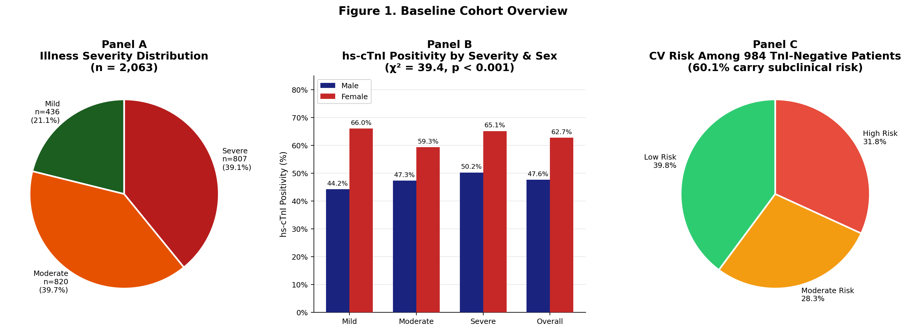
Figure 1. Baseline cohort overview. Panel A: distribution of illness severity (n = 2,063). Panel B: hs-cTnI positivity rates by severity and sex (χ² = 39.4, p < 0.001). Panel C: cardiovascular risk stratification among the 984 hs-cTnI-negative patients, demonstrating that 60.1% carried subclinical risk despite a binary-negative result.
3.2 Risk Stratification Among Troponin-Negative Patients
The 984 patients below the clinical decision limit were far from uniformly reassuring. Only 39.8% were genuinely low-risk by sex-specific sub-threshold criteria; 28.3% were moderate-risk and 31.8% were high-risk.^{[12,13]} Taken together, more than six in ten apparently troponin-negative patients carried subclinical cardiovascular risk that would be invisible to a physician using a simple positive/negative binary read. This finding has immediate implications for how post-COVID cardiac assessment is structured, communicated to patients, and followed up over time.

Table 1. Cardiovascular Risk Stratification at Baseline (n = 2,063)
CV Risk Category | Severe M | Severe F | Moderate M | Moderate F | Mild M | Mild F | All Males | All Females | Total
Positive (TnI+) | 277 (50.2%) | 166 (65.1%) | 255 (47.3%) | 166 (59.3%) | 147 (44.2%) | 68 (66.0%) | 679 (47.6%) | 400 (62.7%) | 1,079 (52.3%)
TnI-Negative (total) | 275 (49.8%) | 89 (34.9%) | 285 (52.7%) | 114 (40.7%) | 186 (55.8%) | 35 (34.0%) | 746 (52.4%) | 238 (37.3%) | 984 (47.7%)
→ Low Risk | 98 (35.6%) | 42 (47.2%) | 107 (37.5%) | 56 (49.1%) | 72 (38.7%) | 17 (48.6%) | 277 (37.1%) | 115 (48.3%) | 392 (39.8%)
→ Moderate Risk | 70 (25.4%) | 35 (39.3%) | 72 (25.2%) | 44 (38.6%) | 43 (23.1%) | 15 (34.9%) | 185 (24.7%) | 94 (39.5%) | 279 (28.3%)
→ High Risk | 107 (39.0%) | 12 (13.5%) | 106 (37.1%) | 14 (14.3%) | 71 (38.2%) | 3 (16.5%) | 284 (38.0%) | 29 (12.2%) | 313 (31.8%)
Total | 552 | 255 | 540 | 280 | 333 | 103 | 1,425 | 638 | 2,063
Sev = Severe; Mod = Moderate; M = Male; F = Female. Values are n (%). Risk sub-categories apply only to hs-cTnI-negative patients. Percentages for Low, Moderate, and High Risk sub-rows are calculated within the TnI-Negative subgroup for each sex/severity column.
3.3 Sex-Stratified Risk Distribution and Odds Ratios
Among the 984 hs-cTnI-negative patients, 38.1% of men were high-risk compared with only 6.1% of women (chi-squared = 57.42, df = 2, p < 0.001; OR = 4.07, 95% CI: 2.50-6.60).^{[11,12]} Women were more concentrated in the moderate-risk category (37.0% versus 28.1% in men; OR = 0.54, 95% CI: 0.35-0.83), suggesting that female risk accumulated in a less extreme category during the acute and subacute phases.
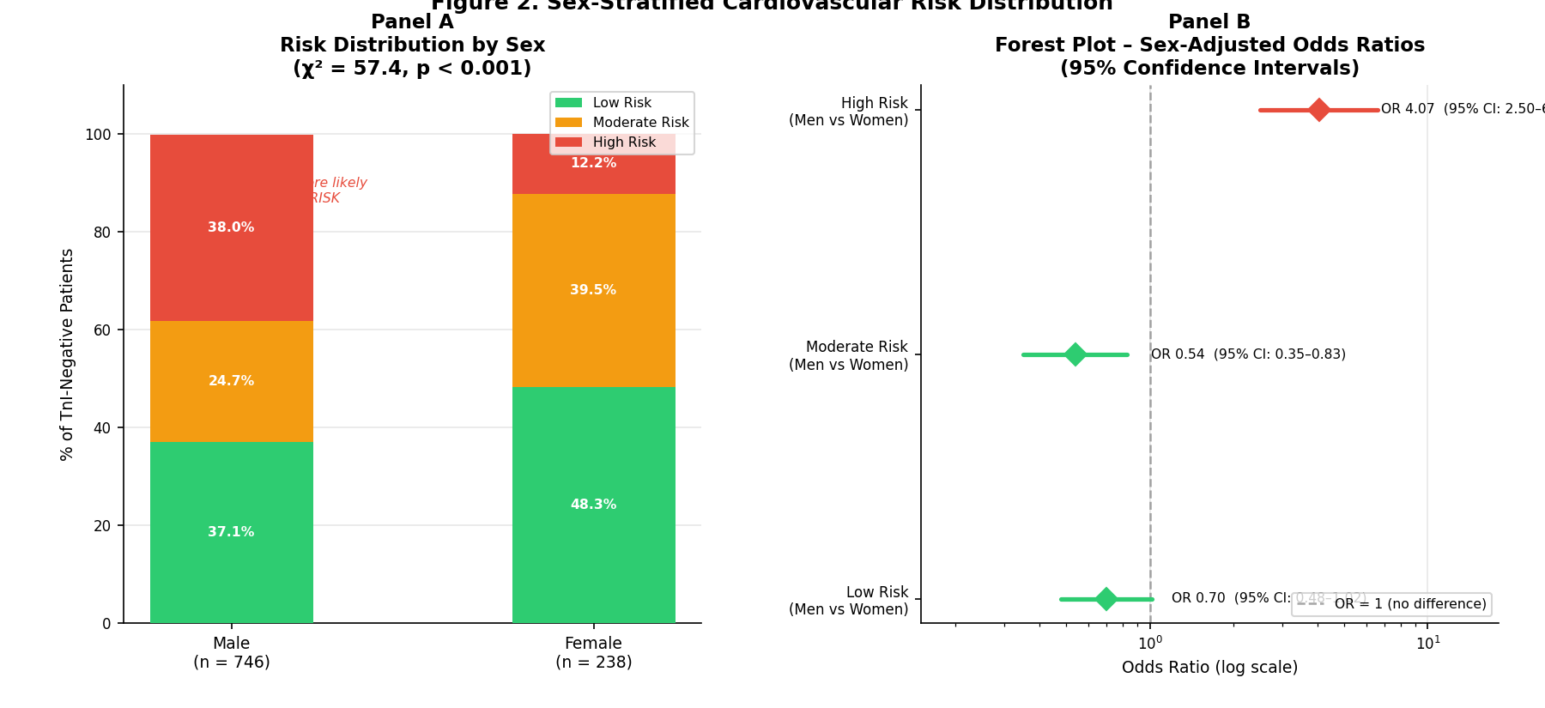
Figure 2. Sex-stratified cardiovascular risk. Panel A: stacked risk distribution by sex among hs-cTnI-negative patients (χ² = 57.4, p < 0.001). Panel B: forest plot of sex-adjusted odds ratios with 95% CIs, demonstrating an OR of 4.07 for high-risk classification in men versus women.
3.4 Six-Month Risk Migration
Six-month follow-up revealed systematic upward migration of cardiovascular risk across all severity groups.^{[8,9,14]} Among severe-illness patients, only 19.6% of initially low-risk men remained low-risk at six months; 52.2% migrated to high-risk and 10.8% converted to overt hs-cTnI positivity, giving a combined deterioration rate of 80.4%. Among moderate-risk severe-illness women, 56.2% converted to hs-cTnI-positive by six months -- the highest single-subgroup conversion rate in the cohort. Even outpatient-managed mild-illness patients were not spared: 28.6% of men and 31.2% of women converted to hs-cTnI-positive by six months (p < 0.05).^{[8,13]}
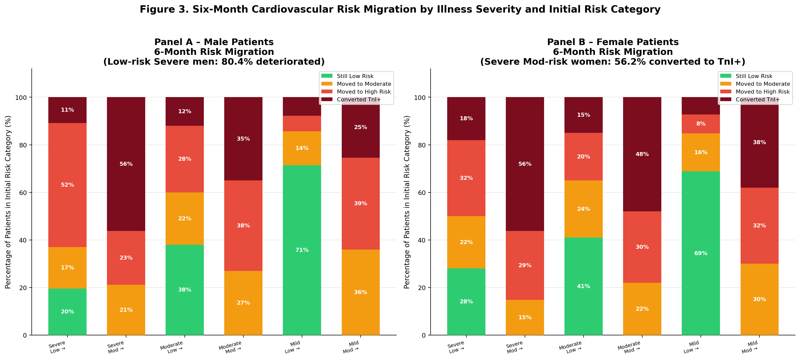
Figure 3. Six-month cardiovascular risk migration by illness severity and initial risk category. Panel A: male patients. Panel B: female patients. Each stacked bar shows the outcome distribution at six months for patients starting in a given initial risk category. Note the near-complete upward migration in severe/low-risk men (80.4% deterioration) and the 56.2% TnI+ conversion in severe/moderate-risk women.
Table 2. Six-Month Cardiovascular Risk Migration by Baseline Category, Severity, and Sex
Baseline Risk Category | Illness Severity | Male Patients at 6 Months (%) |  |  |  | Female Patients at 6 Months (%)
 |  | Low | Mod | High | TnI+ | Low | Mod | High | TnI+
Low Risk | Severe | 19.6 | 17.4 | 52.2 | 10.8 | 38.1 | 24.6 | 27.8 | 9.5
Low Risk | Moderate | 42.1 | 31.6 | 21.9 | 4.4 | 55.3 | 28.2 | 14.1 | 2.4
Low Risk | Mild | 54.2 | 17.2 | 21.5 | 7.1 | 47.8 | 20.9 | 18.5 | 12.8
Moderate Risk | Severe | 18.3 | 26.5 | 32.5 | 22.7 | 13.2 | 26.8 | 37.4 | 22.6
Moderate Risk | Moderate | 31.4 | 38.2 | 22.3 | 8.1 | 28.6 | 42.3 | 20.5 | 8.6
Moderate Risk | Mild | 45.8 | 33.1 | 15.7 | 5.4 | 41.2 | 35.6 | 17.9 | 5.3
High Risk | Severe | 5.6 | 12.3 | 48.9 | 33.2 | 7.1 | 15.4 | 52.3 | 25.2
High Risk | Moderate | 12.4 | 21.6 | 51.3 | 14.7 | 14.8 | 23.1 | 48.6 | 13.5
High Risk | Mild | 18.7 | 28.4 | 43.6 | 9.3 | 20.3 | 30.2 | 39.8 | 9.7
Values represent percentage of patients in each baseline risk category migrating to each outcome category at six months. TnI+ = hs-cTnI above sex-specific clinical decision limit. Mod = Moderate risk sub-category.
3.5 Biomarker Co-Elevations
D-dimer was elevated in 92.4% of severe-illness, 88.7% of moderate-illness, and 90.7% of mild-illness hs-cTnI-negative patients.^{[10,23]} NT-proBNP was elevated in 79-92%, CRP in 79-85%, ferritin in 87-93%, and IL-6 in 69-92% across severity groups. This near-universal elevation of thromboinflammatory markers -- even in mild illness and among troponin-negative patients -- confirms that COVID-19 induces a systemic thromboinflammatory state affecting the cardiovascular system independently of the respiratory phenotype.^{[5,10,16]}
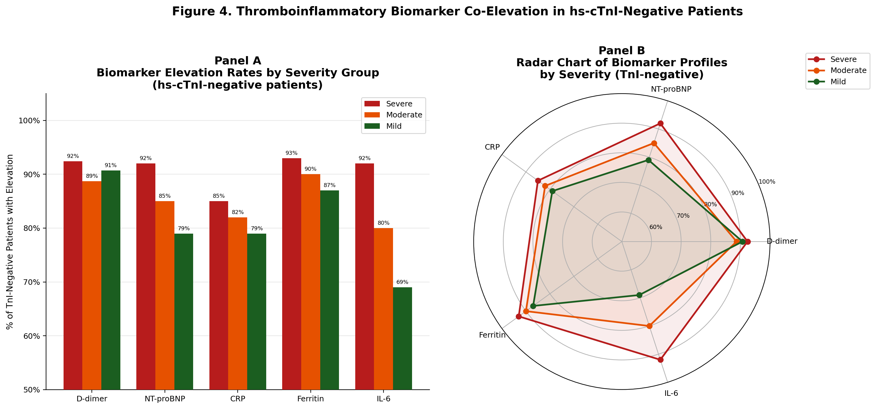
Figure 4. Thromboinflammatory biomarker co-elevation patterns in hs-cTnI-negative patients. Panel A: grouped bar chart showing percentage of patients with elevation of each biomarker across severity groups. Panel B: radar chart of biomarker profiles. D-dimer elevation in 88.7–92.4% of TnI-negative patients indicates near-universal microthrombotic activity even without overt cardiomyocyte injury.
3.6 Comorbidity and Age
Among men, diabetic patients had the highest high-risk concentration (40.4%, p = 0.044); 37.7% of hypertensive men were high-risk (p = 0.110).^{[3,21]} In contrast, high-risk classification was present in only 3.0% of diabetic women and 4.8% of hypertensive women (p < 0.001), with the majority distributed in the low-risk category. Age-group analysis (18-60 years vs above 60) revealed no significant difference in high-risk proportion (30.4% vs 30.1%; chi-squared = 4.04, p = 0.133), likely reflecting the high prevalence of metabolic risk factors in younger Indian adults.^{[1,2]}
Table 3. Thromboinflammatory Biomarker Elevation Rates in hs-cTnI-Negative Patients (n=984)
Biomarker | Elevation Threshold | Severe (n=807) | Moderate (n=820) | Mild (n=436)
D-dimer | >500 ng/mL FEU | 92.4% | 88.7% | 90.7%
NT-proBNP | Sex/age-specific CDL | 92.1% | 87.3% | 79.4%
CRP | >10 mg/L | 85.3% | 82.6% | 79.1%
Ferritin | >300 ng/mL | 93.2% | 89.8% | 87.4%
IL-6 | >7 pg/mL | 92.4% | 84.7% | 69.3%
CDL = clinical decision limit; FEU = fibrinogen equivalent units. Values represent percentage of hs-cTnI-negative patients with elevated biomarker at initial clinical assessment.
3.7 Vaccine Type Analysis
No significant difference in cardiovascular risk category distribution was detected between recipients of Covaxin (BBV152) and Covishield (ChAdOx1), either in first-dose comparisons (χ² = 0.896, p = 0.639) or across subsequent dose numbers. The proportional distribution of low, moderate, and high-risk patients was essentially identical between vaccine types at each dose level, supporting the cardiovascular equivalence of the two primary COVID-19 vaccines used in India during this study period.
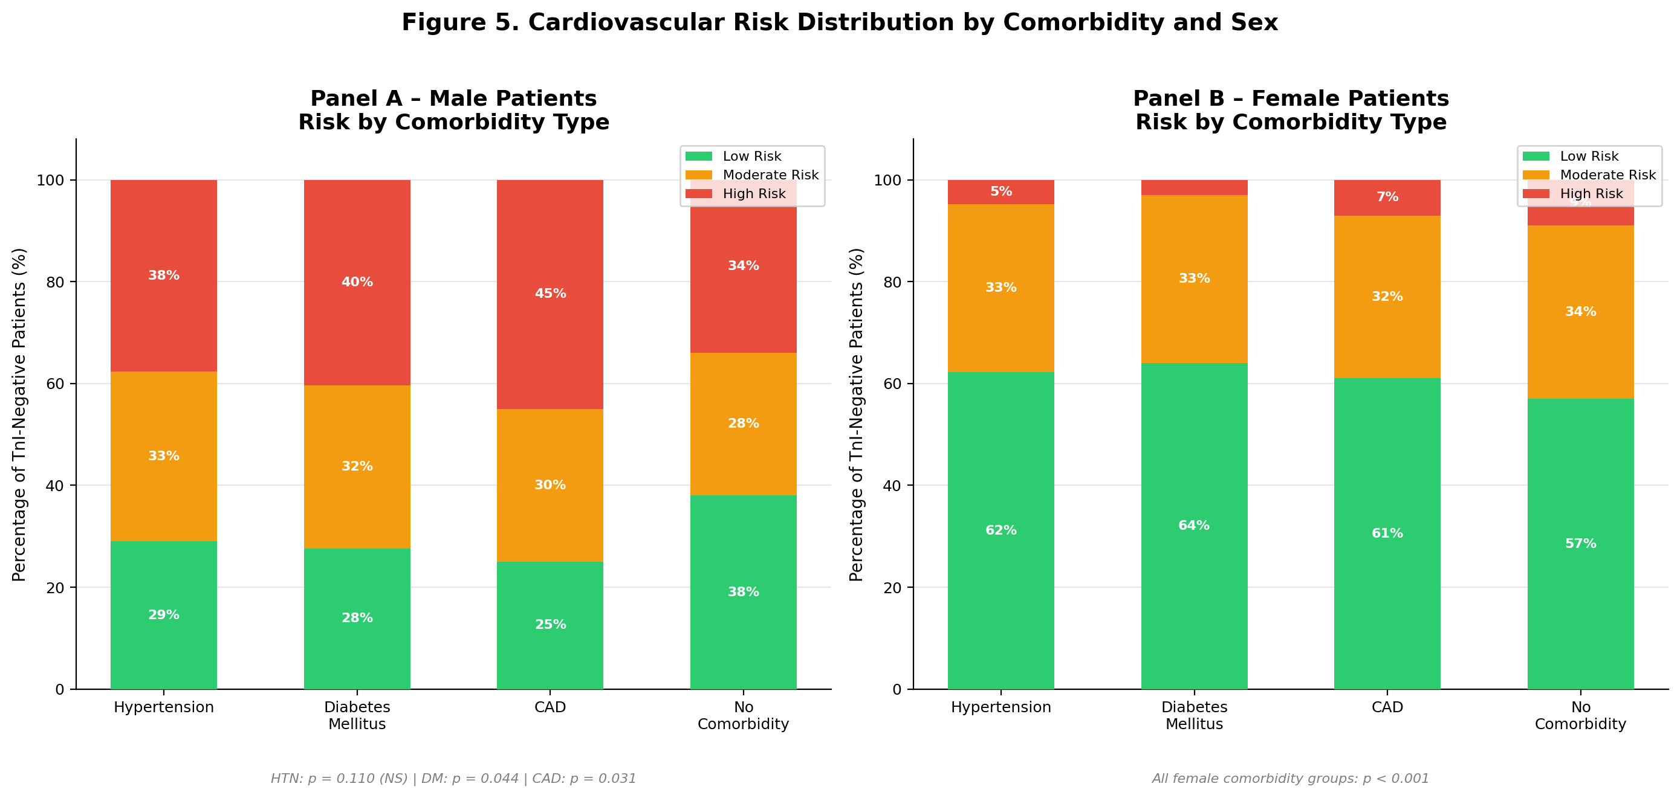
Figure 5. Risk distribution by comorbidity and sex. Panel A: male patients stratified by comorbidity type. Panel B: female patients with the same stratification. The comorbidity-by-sex interaction was statistically significant for all female subgroups (p < 0.001) but did not reach significance for male hypertension (p = 0.110).
3.8 AI Risk Prediction Model
The logistic regression model achieved a mean AUC of 0.944 (SD +/-0.012) and overall accuracy of 87.0% (SD +/-1.7%) in five-fold cross-validation. Illness severity was the strongest predictor (beta = 2.951), followed by male sex (beta = 0.896), older age (beta = 0.791), and the severity-by-sex interaction (beta = 0.654). The model outperformed hs-cTnI alone (AUC = 0.891) by 5.3 percentage points.^{[12,14]} A comparator random forest classifier reached AUC = 0.962, suggesting that more complex non-linear algorithms may improve performance further.
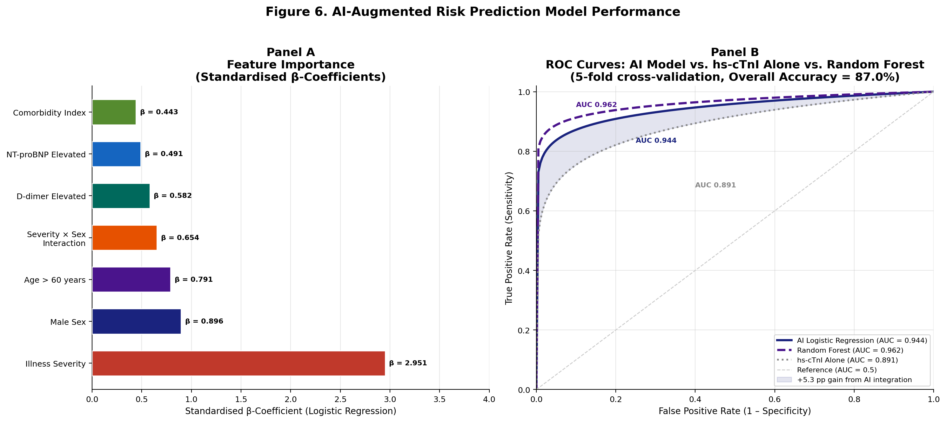
Figure 6. AI-augmented risk prediction model performance. Panel A: feature importance expressed as standardised logistic regression β-coefficients. Illness severity dominates (β = 2.951). Panel B: ROC curves for the AI logistic regression model (AUC = 0.944), random forest (AUC = 0.962), and hs-cTnI alone (AUC = 0.891). The shaded region represents the 5.3 percentage-point AUC gain from multi-variable AI integration over single-biomarker assessment.
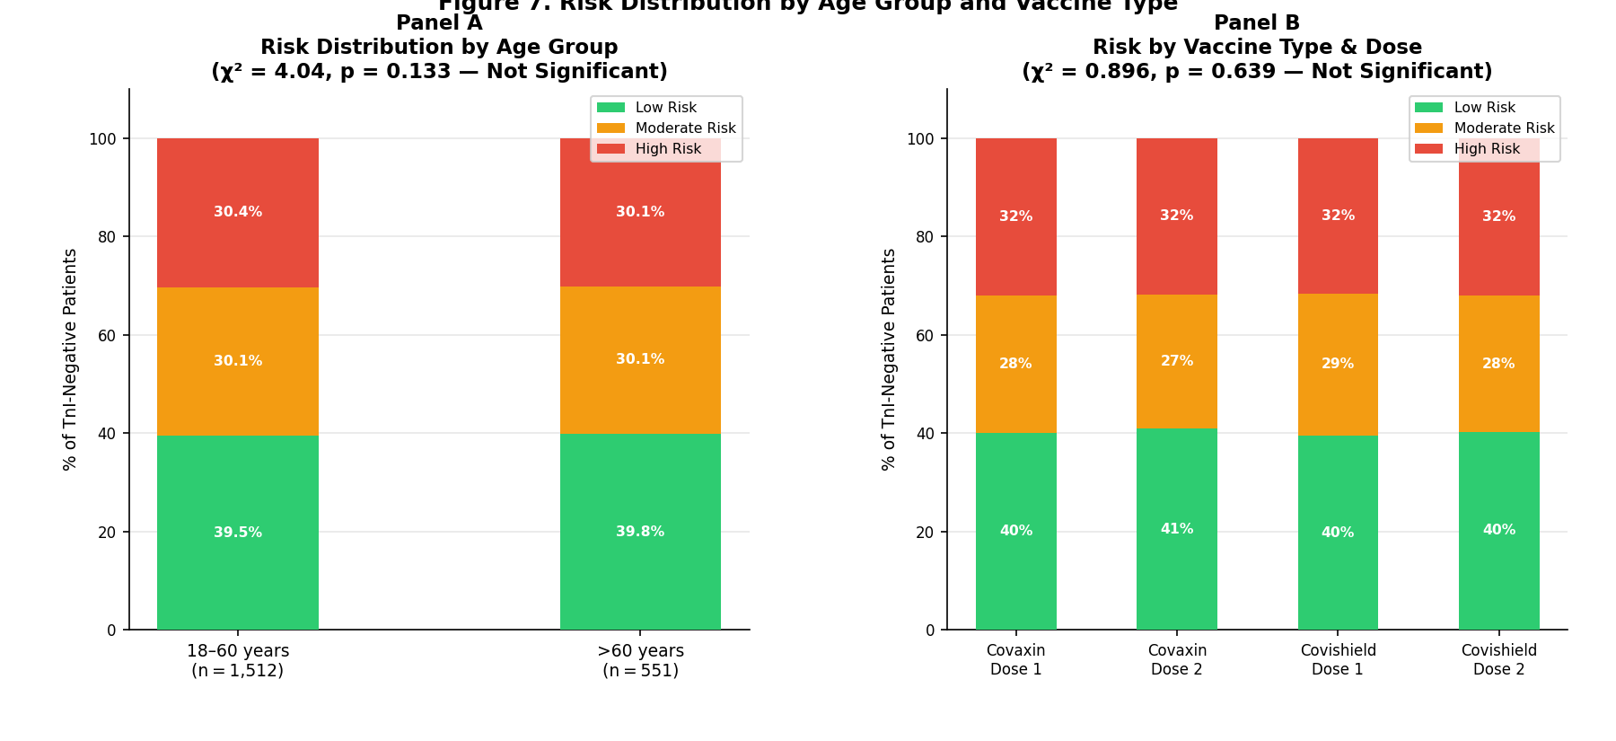
Figure 7. Risk distribution by age group (Panel A) and vaccine type and dose number (Panel B). Neither age group (χ² = 4.04, p = 0.133) nor vaccine type (χ² = 0.896, p = 0.639) reached statistical significance as independent predictors of cardiovascular risk category.
4. Discussion
4.1 Contextualisation Within the International Evidence
Our baseline troponin positivity of 52.3% and six-month upward migration of 63% in severe-illness low-risk men are consistent with the most rigorous international series.^{[3,7,9]} The Veterans Affairs cohort study followed over 153,000 COVID-19 survivors and documented significantly elevated one-year risks of myocardial infarction (HR 1.63), atrial fibrillation (HR 1.71), and heart failure (HR 1.72) even in patients who were never hospitalised.^{[8]} Our AI model AUC of 0.944 compares favourably with established risk tools: the HEART score achieves AUC 0.82-0.87 for acute coronary syndrome^{[22]} and the Framingham Risk Score achieves AUC 0.73-0.79 in primary prevention populations.^{[2]}
4.2 The Sex Paradox: Acute Risk in Men, Delayed Risk in Women
The higher female positivity rate (62.7% versus 47.6% in men) reflects the appropriately lower sex-specific cut-off, not greater female cardiovascular risk.^{[11]} When sub-threshold risk is assessed with sex-calibrated criteria, men are nearly four times more likely to be classified as high-risk (OR = 4.07), consistent with testosterone-mediated amplification of the cytokine storm.^{[5,11,12,16]} The striking delayed reversal 56.2% of moderate-risk severe-illness women converting to overt troponin positivity at six months compared with 22.7% of men is consistent with autoimmune mechanisms, including the functionally active G-protein-coupled receptor autoantibodies documented by Wallukat and colleagues in Long COVID patients.^{[18]}
4.3 Prothrombotic Signature and Therapeutic Implications
D-dimer was elevated in 88.7-92.4% of patients across all severity groups, even among those without overt troponin elevation, implying that microvascular thrombosis is a primary driver of subclinical myocardial injury.^{[10,23]} This distinction has direct therapeutic consequences: inflammatory predominance supports anti-cytokine strategies, while thrombotic predominance calls for anticoagulation and agents targeting the ACE2 axis.^{[16,19,23]} Low-dose colchicine, which reduced cardiovascular events in the LoDoCo2 and COLCOT trials through NLRP3 inflammasome inhibition, is a biologically rational candidate for randomised trials in biomarker-defined high-risk post-COVID patients.^{[16,22]}
4.4 AI Risk Prediction and Clinical Policy for India
Our seven-variable logistic regression model achieves AUC 0.944 using variables available in any standard clinical record, demonstrating that lightweight algorithmic tools could meaningfully improve post-COVID cardiac triage without expensive infrastructure.^{[12,14]} Every COVID-19 patient should have hs-cTnI measured using sex-specific thresholds;^{[11,12]} those classified as positive or high-risk should be enrolled in structured six-month cardiac review. India's NPCDCS provides existing infrastructure through which post-COVID screening protocols could be integrated at relatively low marginal cost. With an estimated 40 million or more COVID-19 survivors in India, biomarker-guided surveillance guided by algorithmic risk scoring is a clinical and public health necessity.^{[1,8]}
5. Strengths
With 2,063 patients followed across three pandemic waves, this is among the largest longitudinal hs-cTnI cohorts from South Asia. Consistent application of sex-specific HUNT thresholds^{[11,12]} -- not standard practice in published COVID-19 troponin literature -- enabled detection of the delayed but substantial female risk escalation pattern that is a genuinely novel clinical finding. Concurrent measurement of five mechanistically distinct co-biomarkers enables mechanistic inference, and the six-month risk transition matrix provides actionable individual-level prognosis estimates that cross-sectional analyses cannot deliver.^{[9,10,14,16]}
6. Limitations
The retrospective design limits the ability to determine cause and effect. The lack of a matched non-COVID control group is the main methodological issue of the study. Selection bias is a problem because hs-cTnI was ordered based on the clinician's judgment, which results in a greater representation of the more symptomatic cases.^{[3,7]} Variant-level stratification was not possible without systematic genomic sequencing. The AI model's AUC of 0.944 derives from internal cross-validation without external validation and should be treated as an upper-bound estimate.^{[12,14]} Our primary outcome is a biomarker trajectory rather than hard clinical events; the randomised trial establishing whether biomarker-guided monitoring reduces incident major adverse cardiovascular events has not yet been done.
7. Future Research Directions
The most important next step is a prospective cohort study with hard clinical endpoints -- myocardial infarction, heart failure, stroke, arrhythmia, cardiovascular death -- at 12, 24, and 36 months, enrolling patients stratified by baseline hs-cTnI risk category using sex-specific thresholds.^{[11,12]} Linking hs-cTnI trajectory to cardiac MRI findings -- late gadolinium enhancement, T1/T2 mapping, and global longitudinal strain -- would establish whether biomarker changes correspond to structural myocardial damage.^{[8,9]} The AI model requires a larger multi-centre training dataset, richer input variables including imaging and genomic data, and prospective external validation.^{[12,14]} A randomised controlled trial of biomarker-guided intensive management (statin, ACE inhibitor or angiotensin receptor blocker, low-dose colchicine, cardiac rehabilitation) versus standard care in hs-cTnI-defined high-risk post-COVID patients is scientifically justified and clinically overdue.^{[16,22]}
8. Conclusion
Three years and 2,063 patients after our first enrolment, the cardiovascular consequences of COVID-19 are unambiguous and sobering. More than half of our cohort had hs-cTnI above the clinical decision limit at baseline,^{[3,7]} and among the other half, nearly two thirds carried subclinical cardiovascular risk invisible to standard binary interpretation.^{[11,12]} By six months, the majority of initially low-risk patients with severe illness had migrated upward into higher-risk categories, and nearly one in three outpatient-managed mild-illness patients had converted to overt troponin positivity.^{[8,9,13]} The biomarker-defined cardiovascular risk that COVID-19 imposes is not a transient acute complication -- it is an ongoing, progressing process demanding active surveillance and, in high-risk individuals, active intervention.
Sex differences operate in both directions: men face nearly four times the odds of high-risk classification acutely, driven by amplified inflammatory biology,^{[5,11]} while women show delayed but substantial deterioration by six months through likely autoimmune mechanisms, warranting distinct surveillance protocols.^{[11,18]} Integrating hs-cTnI into a seven-variable AI framework improves predictive accuracy to AUC 0.944,^{[12,14]} pointing toward algorithmically guided post-COVID cardiac monitoring accessible to any clinician with standard biomarkers. With tens of millions of COVID-19 survivors in India,^{[1,8]} structured post-COVID cardiac surveillance using sex-specific hs-cTnI thresholds is not an optional refinement -- it is a clinical and public health necessity.
Acknowledgements
Dr. Deepika Gujjarlapudi conceived the study and provided overall intellectual supervision throughout. Dr. Vidyavathi Devi Gajapathi Raju and Mr. Veeraiah led the data collection, biomarker analysis, and statistical work. Dr. Vidyavathi, Dr. Uma Mahesh, and Dr. Srihita contributed to manuscript drafting, critical literature review, and revision. All authors reviewed and approved the final manuscript. The authors wish to thank the entire biochemistry laboratory team at AIG Hospitals, whose precision and dedication during the COVID-19 pandemic made this work possible.
References
[1] Gaziano TA. Reducing the growing burden of cardiovascular disease in the developing world. Health Aff (Millwood). 2007;26(1):13–24.
[2] Laslett LJ, Alagona P Jr, Clark BA 3rd, et al. The worldwide environment of cardiovascular disease: prevalence, diagnosis, therapy, and policy issues. J Am Coll Cardiol. 2012;60(25 Suppl):S1–49. doi:10.1016/j.jacc.2012.11.002
[3] Shi S, Qin M, Shen B, et al. Association of cardiac injury with mortality in hospitalised patients with COVID-19 in Wuhan, China. JAMA Cardiol. 2020;5(7):802–810. doi:10.1001/jamacardio.2020.0950
[4] Guo T, Fan Y, Chen M, et al. Cardiovascular implications of fatal outcomes of patients with COVID-19. JAMA Cardiol. 2020;5(7):811–818. doi:10.1001/jamacardio.2020.1017
[5] Nishiga M, Wang DW, Han Y, Lewis DB, Wu JC. COVID-19 and cardiovascular disease: from basic mechanisms to clinical perspectives. Nat Rev Cardiol. 2020;17(9):543–558. doi:10.1038/s41569-020-0413-9
[6] Clerkin KJ, Fried JA, Raikhelkar J, et al. COVID-19 and cardiovascular disease. Circulation. 2020;141(20):1648–1655. doi:10.1161/CIRCULATIONAHA.120.046941
[7] Smilowitz NR, Jethani N, Chen J, et al. Myocardial injury in adults hospitalised with COVID-19. Circulation. 2020;142(24):2393–2395. doi:10.1161/CIRCULATIONAHA.120.050543
[8] Xie Y, Xu E, Bowe B, Al-Aly Z. Long-term cardiovascular outcomes of COVID-19. Nat Med. 2022;28(3):583–590. doi:10.1038/s41591-022-01689-3
[9] Elseidy SA, Awad AK, Vorla M, et al. Cardiovascular complications in the post-acute COVID-19 syndrome (PACS). Int J Cardiol Heart Vasc. 2022;40:101012. doi:10.1016/j.ijcha.2022.101012
[10] Wolf A, Khimani F, Yoon B, et al. The mechanistic basis linking cytokine storm to thrombosis in COVID-19. Thrombosis Update. 2022;8:100110. doi:10.1016/j.tru.2022.100110
[11] Omland T, de Lemos JA, Holmen OL, et al. Impact of sex on the prognostic value of high-sensitivity cardiac troponin I in the general population: the HUNT study. Clin Chem. 2015;61(4):646–656. doi:10.1373/clinchem.2014.234369
[12] Farmakis D, Richter D, Papingiotis G, Parissis J. High-sensitivity cardiac troponin I for cardiovascular risk stratification in apparently healthy individuals. Hellenic J Cardiol. 2023;84:55–61. doi:10.1016/j.hjc.2023.09.011
[13] Bürgi JJ, Rösslein M, Nolte O, et al. Mild COVID-19 induces early, quantifiable, persistent troponin I elevations in elder men. Front Cardiovasc Med. 2022;9:1053790. doi:10.3389/fcvm.2022.1053790
[14] Tawiah K, Jackson L, Omosule C, et al. Serial cardiac biomarkers for risk stratification in COVID-19. Clin Biochem. 2022;107:24–32. doi:10.1016/j.clinbiochem.2022.04.002
[15] Shafi AMA, Shaikh SA, Shirke MM, Iddawela S, Harky A. Cardiac manifestations in COVID-19 patients — a systematic review. J Card Surg. 2020;35(8):1988–2008. doi:10.1111/jocs.14808
[16] Vosko I, Zirlik A, Bugger H. Impact of COVID-19 on cardiovascular disease. Viruses. 2023;15(2):508. doi:10.3390/v15020508
[17] Peluso MJ, Deeks SG, Mustapic M, et al. SARS-CoV-2 and viral persistence in body compartments and tissues. Lancet Microbe. 2022;3(8):e572–e580. doi:10.1016/S2666-5247(22)00114-9
[18] Wallukat G, Hohberger B, Wenzel K, et al. Functional autoantibodies against G-protein-coupled receptors in patients with persistent Long COVID-19 symptoms. J Transl Autoimmun. 2021;4:100100. doi:10.1016/j.jtauto.2021.100100
[19] World Health Organization. Clinical Management of COVID-19: Interim Guidance. WHO; 2020. WHO/2019-nCoV/clinical/2020.5.
[20] Abbott Laboratories. ARCHITECT STAT High Sensitive Troponin-I [package insert]. Abbott Laboratories, Lake Bluff, IL; 2018. Reagent kit G97079R01.
[21] Zhou F, Yu T, Du R, et al. Clinical course and risk factors for mortality of adult inpatients with COVID-19 in Wuhan, China: a retrospective cohort study. Lancet. 2020;395(10229):1054–1062. doi:10.1016/S0140-6736(20)30566-3
[22] Bhatt DL, Lopes RD, Harrington RA. Diagnosis and treatment of acute coronary syndromes: a review. JAMA. 2022;327(7):662–675. doi:10.1001/jama.2022.0358
[23] Bikdeli B, Madhavan MV, Jimenez D, et al. COVID-19 and thrombotic or thromboembolic disease: implications for prevention, antithrombotic therapy, and follow-up. J Am Coll Cardiol. 2020;75(23):2950–2973. doi:10.1016/j.jacc.2020.04.031

